**Frontend Development with React.js**

**Project Documentation format Insight Steam**

1. **Introduction**
   * **Project Title: Insight stream**
   * **Team Members**:

**Karthick S (Team Leader)** [Email id: saravanankarthick36@gmail.com]

**Deepak Raj L** [Email id: deepakrajdeepakraj2004@gmail.com]

**Bharathan K** [Email id : naveen.mass47@gmail.com]

**iyyappan E** [Email id : [iyyappanelumalai007@gmail.com](mailto:iyyappanelumalai007@gmail.com)]

**Akash.H** [Email id:akashaakash72456@gmail.com]

1. **Project Overview**
   * **Purpose**:

Karthick News App is a web application designed to provide users with the latest news updates from various categories. The application fetches news articles from APIs and presents them in a user-friendly format.

* + **Features**:

•Fetch and display real-time news articles

•Search functionality to find relevant news

•Category-wise filtering (Politics, Sports, Technology, etc.)

•User authentication (Login/Signup for personalized experience)

•Responsive design for mobile and desktop

1. **Architecture**
   * **Component Structure**:

The application is built using React.js with a component-based architecture. Major components include:

•Header: Contains the navigation bar and search bar.

•NewsCard: Displays individual news articles with images and descriptions.

•CategoryFilter: Allows users to filter news by category.

•SearchPage: Enables users to search for specific news articles.

•HomePage: Displays trending and latest news articles.

•ArticlePage: Shows the full content of a selected news article.

* + **State Management**:

•The application uses Redux (or React Context API) for managing global state.

•Manages user authentication, news categories, and search results.

* + **Routing**:

The application uses React Router for navigation. Routes include:

• /: Home Page

• /search: Search Page

• /category/:name: Category-wise news page

• /article/:id: Detailed news article page

• /login: User login page

1. **Setup Instructions**
   * **Prerequisites**:

•Node.js (v16 or higher)

•npm (v8 or higher)

•Git

* + **Installation**:

1. Clone the repository:

git clone <https://github.com/yourusername/karthick-news-app.git>

1. Navigate to the client directory:cd karthick-news-app/client
2. Install dependencies :npm install
3. Configure environment variables:

•Create a .env file in the client directory

•Add necessary variables (e.g., API keys for news sources)

1. Start the development server:npm start npm start The application will be available at <http://localhost:3000>
2. **Folder Structure**
   * **Client**:

karthick-news-app/

│── src/

│ ├── components/ # Reusable components (Header, NewsCard, etc.)

│ ├── pages/ # Page components (HomePage, SearchPage, etc.)

│ ├── assets/ # Images, icons, and other static files

│ ├── redux/ # Redux store, actions, and reducers (if using Redux)

│ ├── utils/ # Utility functions and API calls

│ ├── App.js # Main application component

│ └── index.js # Entry point

1. **Running the Application**

To start the frontend server, run: npm start

1. **Component Documentation**
   * **Key Components**:

•Header: Displays navigation and search bar.

•Props: onSearch (function to handle search queries).

•NewsCard: Displays a news article.

•Props: article (object containing article details).

•CategoryFilter: Allows users to filter news by category.

•Props: categories (array of available categories), onSelect (callback function).

.

1. **State Management**
   * **Global State**:

•user: Current authenticated user

•news: Fetched news articles

•searchResults: News articles based on search queries

•selectedCategory: Currently selected news catego

* + **Local State**:

• searchQuery: Manages search input state in the SearchPage component.

1. **User Interface**

Screenshots

•Home Page: Displays trending news and categories

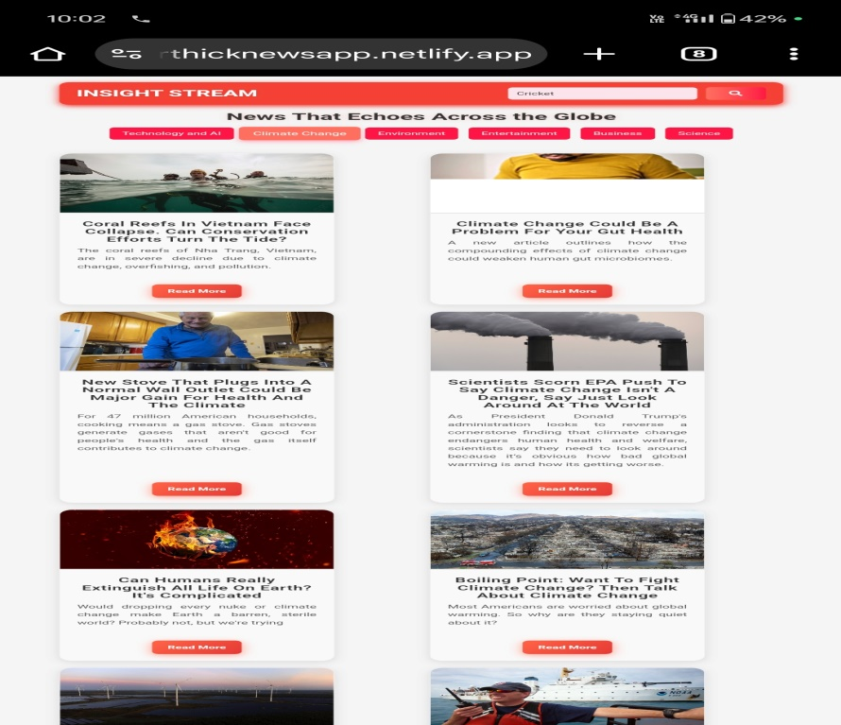

•Search Page: Allows users to search for news

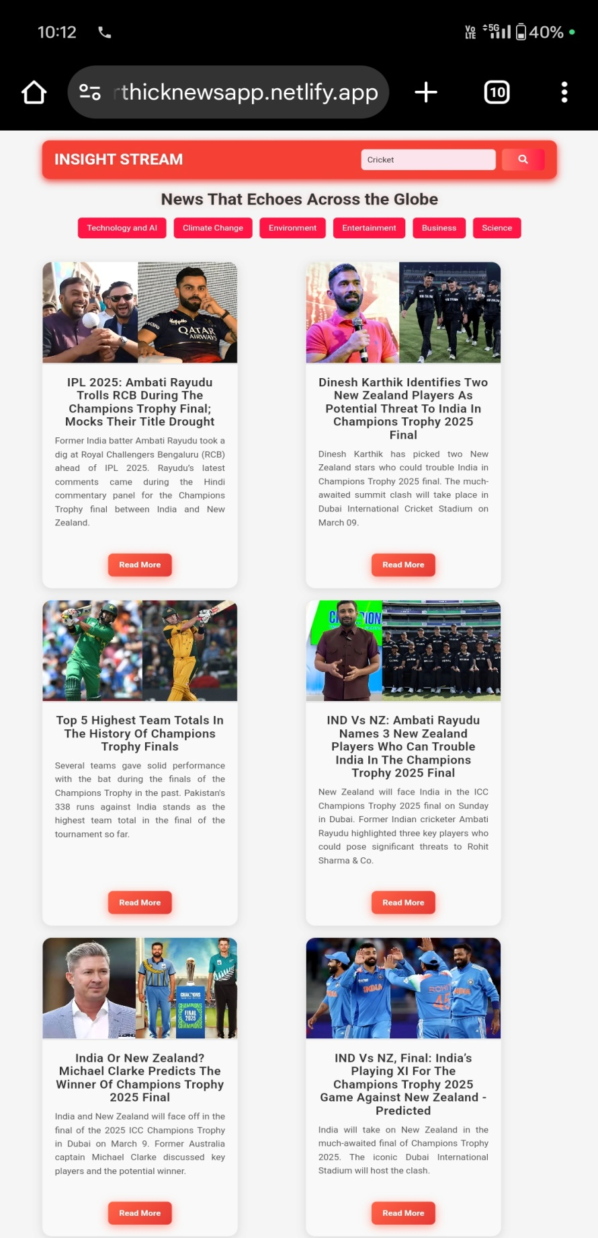

•Article Page: Displays full news article

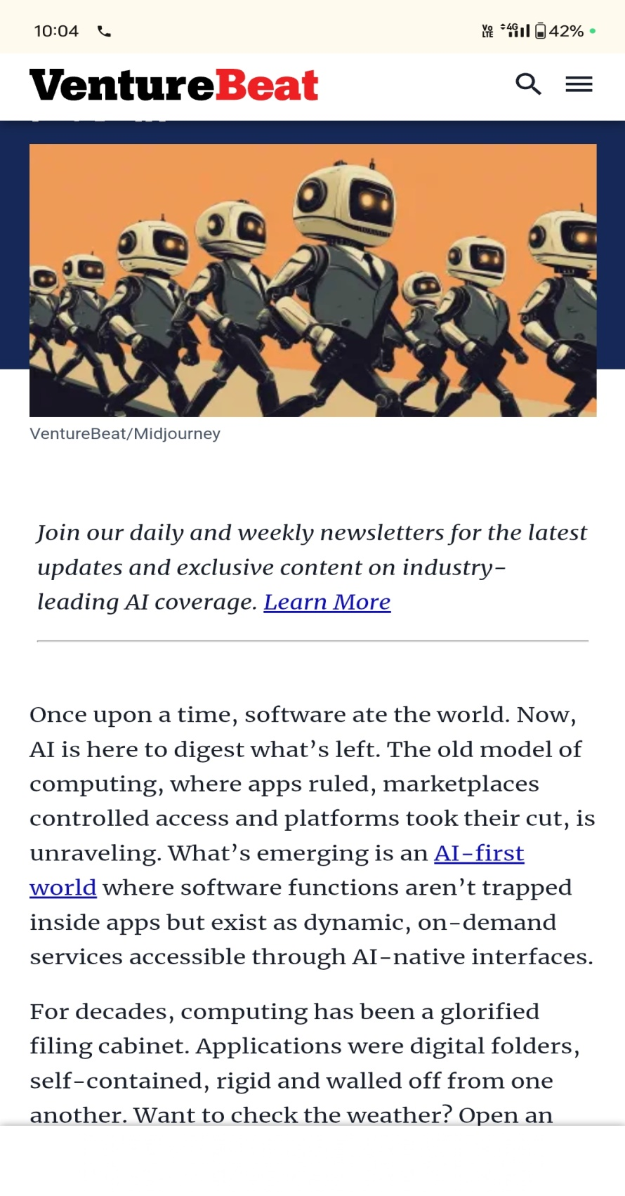

1. **Styling**

* **CSS Frameworks/Libraries** :
  + Styled-Components for modular styling

1. **Theming**:
   * Supports light and dark modes
2. **Testing**

* **Testing Strategy**:

•Unit Testing: Using Jest and React Testing Library

•Integration Testing: Ensures components work together

•End-to-End Testing: Cypress is used for testing user flows.

1. **Screenshots or Demo**

• Live Demo: karthicknewsapp.netlify.app

1. **Known Issues**

•Issue 1: API request limits may cause some news articles to load slowly.

•Issue 2: Search results sometimes display outdated news articles..

1. **Future Enhancements**

• Implement a bookmark feature for users to save favorite articles.

• Add user profiles with personalized news preferences.

• Enhance UI with animations and smooth transitions.

• Introduce push notifications for breaking news alerts.

This document serves as a structured overview of the Karthick News App, detailing its architecture, features, and future improvements. Let me know if you’d like any modifications!